AI BLOGNEST

Team Leader: Sharmila.S
[ sac2427csc5342@ssacollegechennai.com ]
REG NO: 222409494
Team Members:
Shabana.A
[ sac2427csc5315@ssacollegechennai.com ]
REG NO:222409493
Sneha.D
[ sac2427csc5364@ssacollegechennai.com ]
REG NO:222409496
Sri Harini.Y
[ sac2427csc5335@ssacollegechennai.com ]
REG NO:222409497

Executive Summary
AI BlogNest is a secure REST API backend built with Node.js, Express.js and MongoDB. Users can register, log in, create and fetch blogs, and use Google Gemini AI to generate blog posts and summarise content. The target user is Priya, a content creator who manages many blogs and needs organised content, role-based collaboration and faster writing. This report summarises the project across its eight phases.
Phase | Topic | Outcome
1 | Brainstorming & Ideation | Problem, ideas and scope finalised.
2 | Requirement Analysis | Functional, non-functional, software and hardware requirements.
3 | Project Design | Architecture, MVC, ER diagram, user flow and API design.
4 | Project Planning | Epics, timeline, tools and risks.
5 | Project Development | Server, database, models, authentication, blog and AI modules.
6 | Project Testing | Six API test cases executed and passed.
7 | Project Documentation | README, API reference, setup and troubleshooting.
8 | Project Demonstration | Demo flow, links, results and conclusion.

Phase 1: Brainstorming & Ideation
Problem: Priya struggles with managing drafts, categories and tags, limited visibility into post performance, slow approval and comment moderation, no media handling and no permission tiers for editors, authors and admins.
Solution: A centralized, secure API that separates business logic from the front end, with a role-based permission matrix and services for blogs, AI generation and summarisation.
Idea | Decision
JWT authentication with role-based access; blog CRUD | Core (MVP)
AI blog generation and AI summarisation | Core (MVP)
Categories, tags, comment moderation, media paths | Planned
Post scheduling, analytics dashboard, AI quality audit | Future scope

Phase 2: Requirement Analysis

Functional Requirements
ID | Requirement | Role
FR-01 | Register users with name, email and password (stored hashed). | All
FR-02 | Log in with email and password and receive a JWT token. | All
FR-03 | Verify the JWT on protected routes; reject invalid or missing tokens. | All
FR-04 | Create blogs linked to the logged-in author. | Author / Admin
FR-05 | Fetch all blogs with author details. | All
FR-07 | Generate a blog from topic and category using Gemini AI. | Author / Admin
FR-08 | Summarise supplied content using Gemini AI. | Author / Admin
FR-09 | Manage users and roles; moderate comments. | Admin / Editor

Non-Functional Requirements
- Security: JWT, bcrypt hashing, input sanitisation, rate limiting.
- Performance: CRUD responses well under a second; AI calls a few seconds.
- Maintainability: modular MVC folders; centralized error handling.
- Portability: Windows, macOS and Linux.

Software and Hardware Requirements
Category | Requirement
Software | Node.js v16+, npm v8+, Express.js, MongoDB + Mongoose, Postman / Thunder Client, VS Code, Gemini API key
Hardware | Intel Core i5 (8th gen) / AMD Ryzen 5, 8 GB RAM (16 GB recommended), 1 GB free storage
Environment variables | PORT, MONGO_URI, JWT_SECRET, GEMINI_API_KEY

User Roles
Role | Responsibility
Admin | Full control: manage users and roles, remove malicious comments, inspect logs.
Editor | Review drafts, publish posts, moderate comments.
Author | Create and manage own posts; use AI generation and summarisation.
Reader | Read published posts and comment.

Phase 3: Project Design
Requests pass through middleware (authentication, authorization, validation, error handling), then controllers, which use Mongoose models for MongoDB or the AI layer for Gemini.
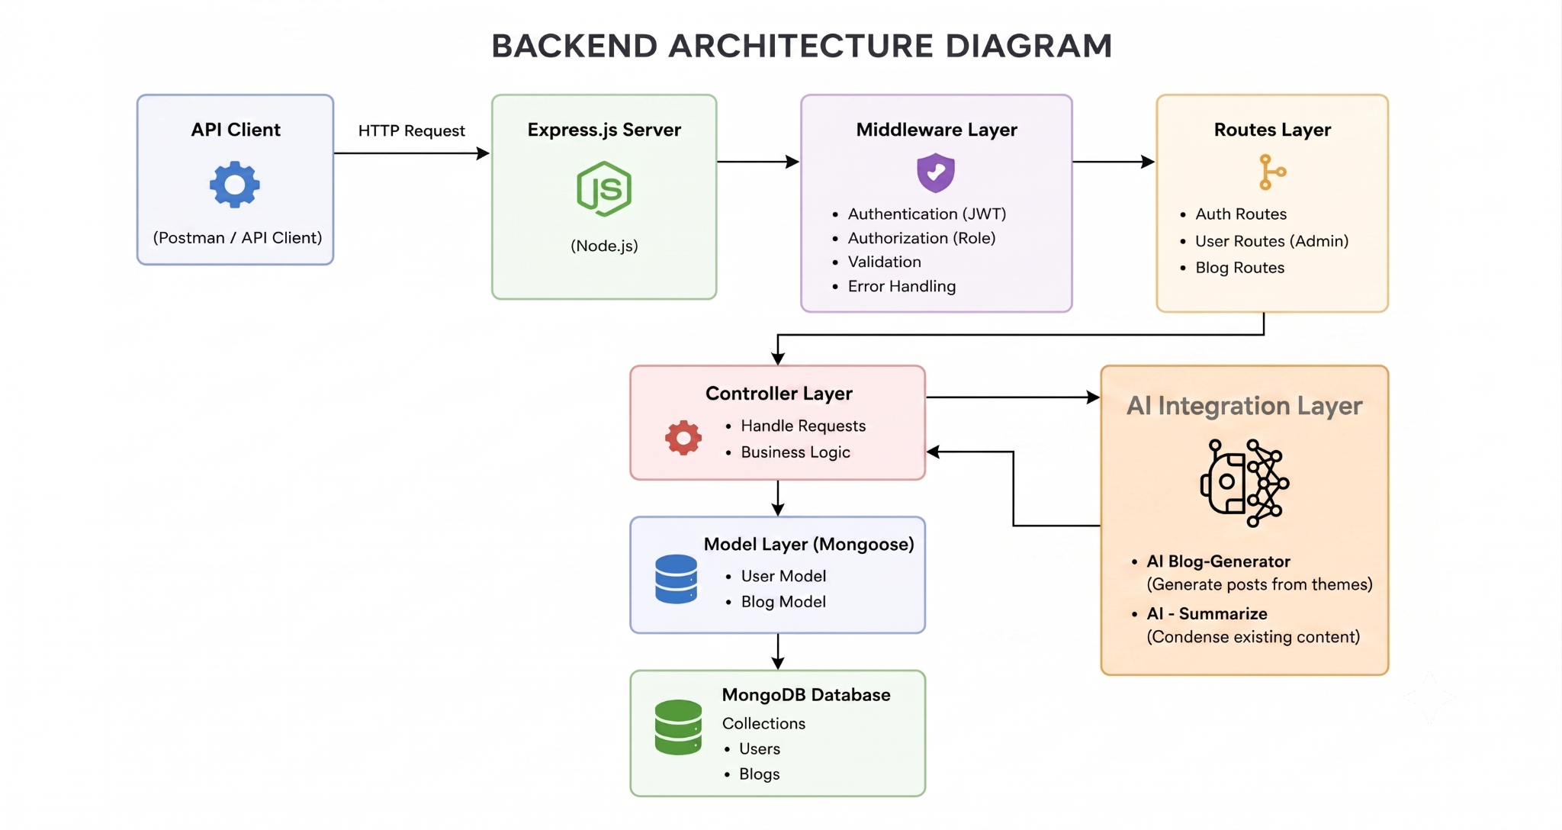
Figure 1: Backend architecture diagram
The project follows the MVC pattern: models are Mongoose schemas, controllers hold the business logic and the routing layer acts as the view in this headless API.

Figure 2: MVC architecture

Database Design and User Flow
  Figure 3: ER diagram | 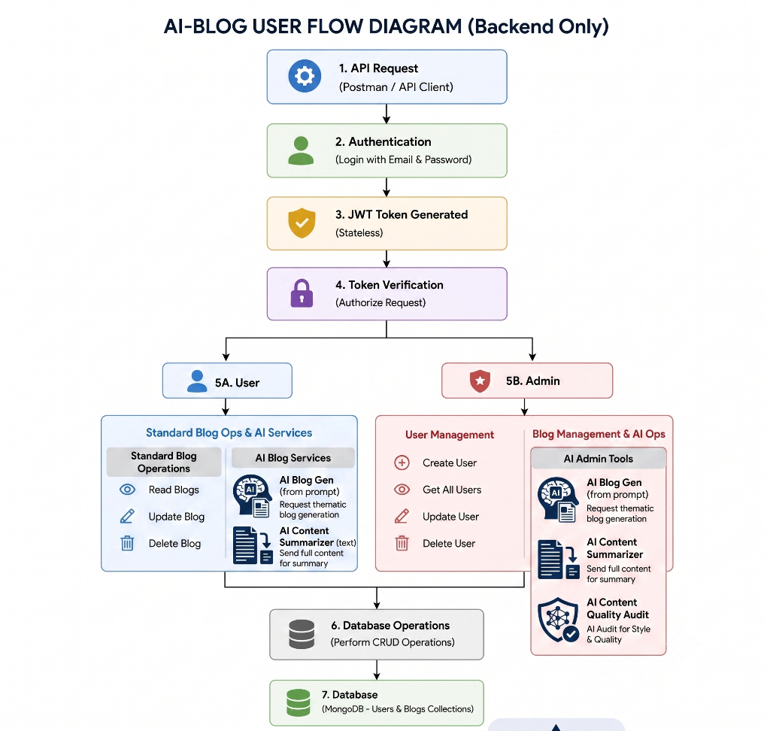  Figure 4: User flow

API Design
Method | Endpoint | Access | Description
POST | /api/auth/register | Public | Register a new user
POST | /api/auth/login | Public | Login and receive JWT
POST | /api/blogs | Token | Create a blog
GET | /api/blogs | Public | Fetch all blogs
POST | /api/ai/generate-blog | Token | Generate and save AI blog
POST | /api/ai/summarize | Token | Summarise content

Security Design
- Passwords hashed with bcrypt; JWT sent as Authorization: Bearer token.
- Role-based middleware guards sensitive routes; secrets kept in .env.

Phase 4: Project Planning

Epic Breakdown
Epic | Name | Deliverable
1 | Project Architecture | Architecture, ER and flow diagrams
2 | Setup & Configuration | Project folders, npm init, packages
3 | Backend Development | server.js, app.js, routes, controllers, middleware
4 | Database Configuration | MongoDB connection and Mongoose models
5 | Execution & Testing | All APIs verified in Postman / Thunder Client

Suggested Timeline
Stage | Duration
Ideation and requirements | Day 1–3
Design | Day 3–4
Setup and development | Day 5–9
Testing | Day 9–10
Documentation and demonstration | Day 10–12

Risks and Mitigation
Risk | Mitigation
Missing MONGO_URI | Checked at start-up; server exits with a clear message.
Invalid Gemini key or quota | Error handling in the AI service.
Unauthorised access | JWT and role middleware on protected routes.
Slow AI calls | Kept separate from core CRUD requests.

Project Folder Setup
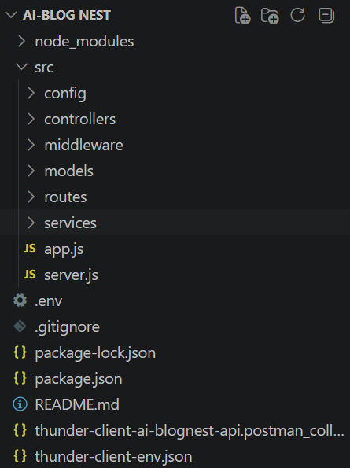
Figure 5: Project structure in VS Code

Phase 5: Project Development
Setup: run npm init -y, install express, mongoose, dotenv, cors, morgan, jsonwebtoken, bcryptjs and the Gemini SDK, and create a .env file. Source folders: config, controllers, middleware, models, routes and services.
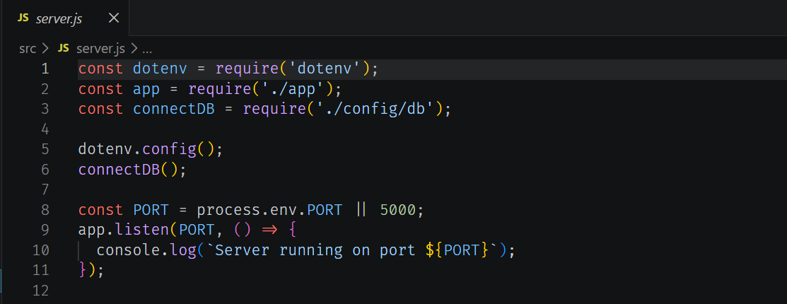  Figure 6: server.js | 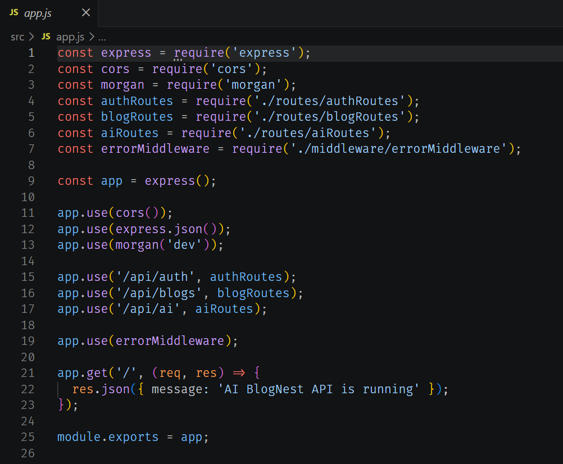  Figure 7: app.js
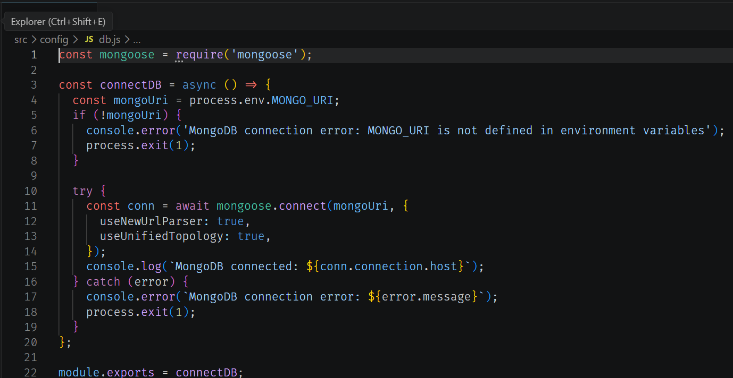  Figure 8: config/db.js | 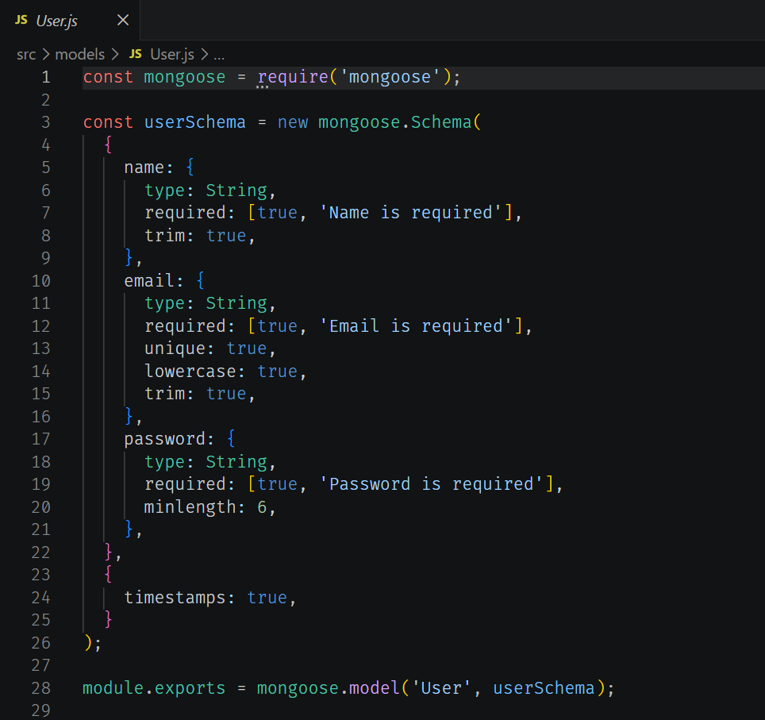  Figure 9: models/User.js
- Auth: passwords hashed with bcrypt; login returns a signed JWT; middleware verifies it.
- Blogs: POST /api/blogs stores title, content, category and author; GET /api/blogs returns blogs with author details.
- AI: /api/ai/generate-blog creates and saves a blog; /api/ai/summarize returns a short summary.

Phase 6: Project Testing
ID | Test case | Expected | Actual | Status
TC-01 | Register user | 201 Created | 201, 140 ms | Pass
TC-02 | Login | 200 OK + JWT | 200, 146 ms | Pass
TC-03 | Create blog (token) | 201 Created | 201, 59 ms | Pass
TC-04 | Fetch blogs | 200 OK + list | 200, 92 ms | Pass
TC-05 | AI generate blog | 201 Created | 201, 4.12 s | Pass
TC-06 | AI summarise | 200 OK + summary | 200, 5.67 s | Pass

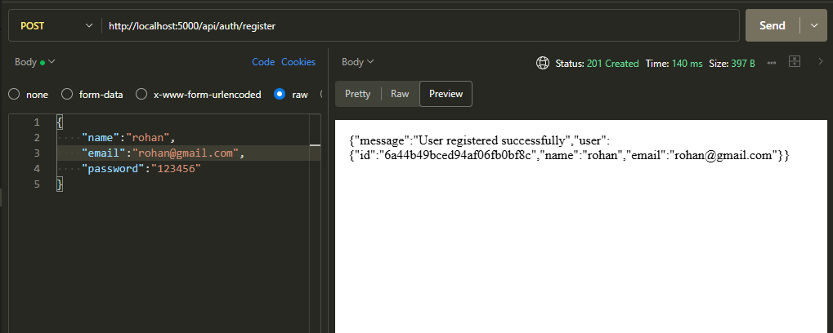  Figure 10: Registration | 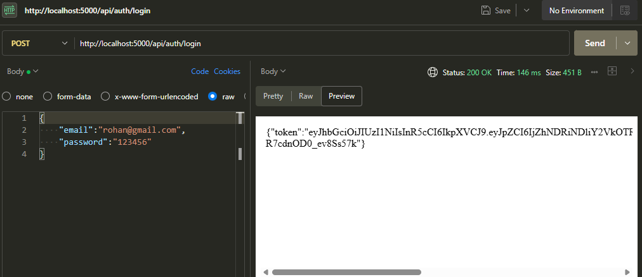  Figure 11: Login
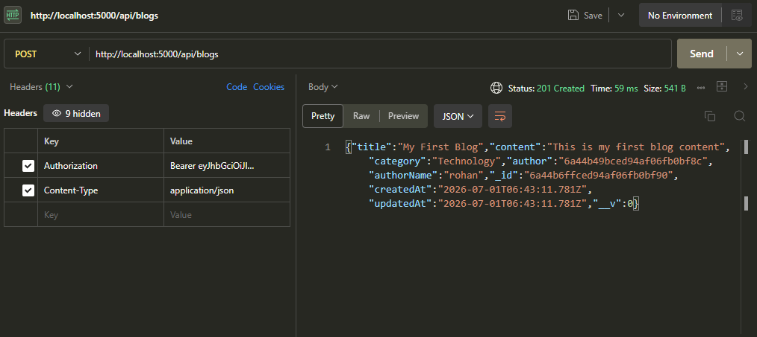  Figure 12: Create blog | 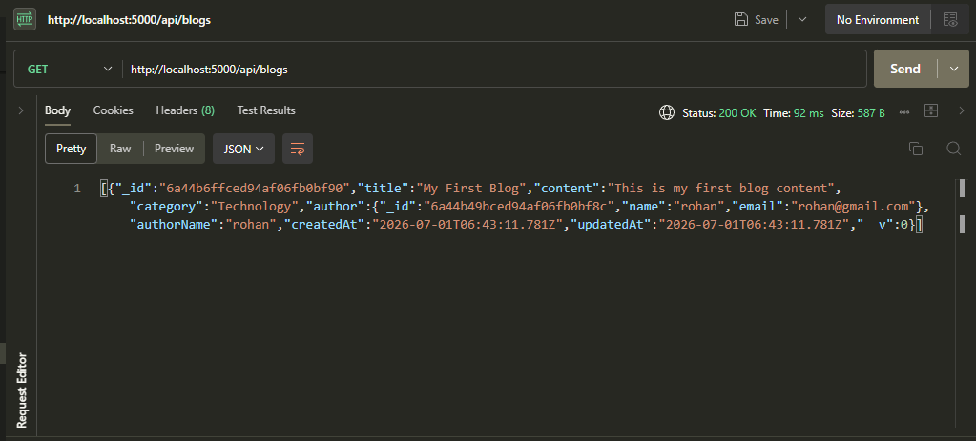  Figure 13: Fetch blogs
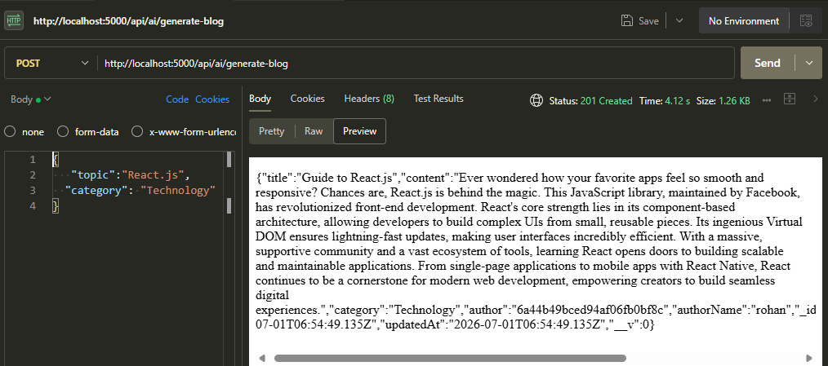  Figure 14: AI generation | 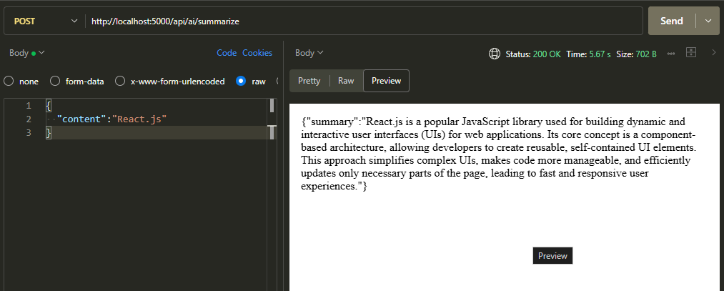  Figure 15: AI summarisation
Result: all six tests passed. CRUD calls respond in under 150 ms; AI calls take about 4–6 seconds because of the external model.

Phase 7: Project Documentation

Deliverables
- README.md, eight phase documents, this overall report, the Thunder Client / Postman collection and the demo video.

Run Guide
- Install Node.js and MongoDB, clone the repository and run npm install.
- Create the .env file (PORT, MONGO_URI, JWT_SECRET, GEMINI_API_KEY).
- Start with npm start; the console shows "Server running on port 5000".
- Open Postman or Thunder Client and call the APIs.

Sample Request Bodies
Endpoint | Body
POST /api/auth/register | { "name", "email", "password" }
POST /api/auth/login | { "email", "password" }
POST /api/blogs | { "title", "content", "category" }
POST /api/ai/generate-blog | { "topic", "category" }
POST /api/ai/summarize | { "content" }

Troubleshooting
Problem | Fix
MONGO_URI is not defined | Add MONGO_URI to .env and restart.
401 Unauthorized | Log in again and send Authorization: Bearer <token>.
AI endpoint fails | Check GEMINI_API_KEY, quota and internet connection.
Port already in use | Change PORT in .env or stop the other process.

Future Scope
- Update / delete blogs, comments and moderation, categories and media.
- Post scheduling, analytics, automated tests and cloud deployment.

Phase 8: Project Demonstration
Item | Link
GitHub Repository Link | [Paste your repository link here]
Demo Video Link | [Paste your demo video link here]
API Testing Video | [Paste your API testing video link here]
Code Drive Link | [Paste your Google Drive code link here]

Demo Flow
- Introduce the problem and the AI BlogNest solution.
- Show the project structure and start the server.
- Register a user, log in and copy the JWT token.
- Create a blog and fetch all blogs.
- Generate a blog with AI and summarise content.
- Close with results and future scope.

Results Achieved
Goal | Result
Secure registration and login | Achieved – JWT issued on login
Blog creation and retrieval | Achieved – linked to author
AI blog generation | Achieved – blog generated and saved
AI summarisation | Achieved – concise summary returned
Layered, maintainable code | Achieved – MVC structure

Conclusion
AI BlogNest shows how a secure Node.js and MongoDB backend can be combined with Generative AI to reduce the effort of blog creation and management. All core objectives were met and tested, and the project is a solid base for adding comments, roles, analytics and a front end.

